Family Paideia Seminar Plan
Text: The Einstein Refrigeration Patent by Albert Einstein and Leo Szilard
Ideas, Values: Change, Element, Technology, Government
Pre-Seminar Content
Big Ideas Chat:
To successfully apply for a patent, it is required of the inventor that the invention be an absolute novelty. This means that no one can have invented or published a version of the invention before filing for the patent.
For what invention idea would you consider applying for a patent? Where did the idea come from?

1st Read: Non labeled version
(https://www.wired.com/2009/11/1111einstein-szilard-refrigerator/)

Display a large version of Einstein’s refrigeration patent sketch, prior to the discussion, either on a computer screen on a printout. Allow family members to make predictions and discuss how the invention might work as time permits.

Vocabulary:
Discuss with family members any vocabulary that they will need to interpret the sketch. Consider doing a little background research on thermodynamics and chemical reactions if you want to take the discussion further. For younger children discuss the idea of technology and novelty. In addition, talk about how heating something up can make something cooler.

2nd Read: Labeled version
(https://www.edn.com/einstein-patents-a-refrigerator-design-november-11-1930/)

Display a large version of Einstein’s refrigeration patent sketch with labels, prior to the discussion, either on a computer screen on a printout.

Pre-Seminar Process:
- Share why you are having the discussion.
(Sample script from our classroom Paideia Seminars: Modify to fit your household.)
“A Paideia seminar is a collaborative, intellectual dialogue about a text, facilitated with open ended questions.”
“The main purpose of seminar is to arrive at a fuller understanding of the textual ideas and values, of ourselves, and of each other.”

- Describe what you want to accomplish.
- Set a Family Goal.
- To balance the talk time
- To refer to the text
- To ask a question
- To speak out of uncertainty
- To build on others’ comments

Seminar Questions:

- Opening (Identify main ideas from the text):
  - What do you think is the most important invention in your house? Have younger kids share first if they feel comfortable and advance by age.
(Don’t share your why until after everyone has had a chance to answer.)

  - Why did you pick that invention? (Anyone can share)

- Core (Analyze textual details):

  - What surprises you about this refrigeration patent sketch?

  - Why do you think Einstein and Szilard would see the value in creating refrigeration with no moving parts or without electricity?

  - When something is invented, does it matter if it gets patented or produced? Why?

  - What do you think Einstein and Szilard needed to know about heating and cooling liquids and gases to make this refrigeration unit work?

  - If you were the patent clerk, what clarifying questions would you ask the inventors before you approved or denied the patent? (Why this question?)

- Closing (Personalize and apply the ideas):

  - If you could design a better refrigerator what would you add to it or remove from it? Does the cost matter?
Post-Seminar Process:

“Ask each person what they liked most about the discussion.”

- Have the family do a quick check of the discussion goal.

Post Seminar Content:

- Brainstorm:
Review and discuss key ideas that you heard, said and thought during the family seminar. Think about what was said about improving a crucial appliance like a refrigerator.

Sometimes the best opportunities for creativity, innovation, and inventing are when we have time and isolation. Think about how your life has changed with more time at home. What items do you use more now? What items are missing?

- Family Activity
Host a design challenge. Each family member should sketch out a design for a new household invention to make life at home a little easier. Take turns pitching the invention to a family patent committee and decide whose patent gets approved and whose needs a redesign. Have a family member take a photo of the patented designs and share with a friend or relative along with this Paideia Family Plan.

This Paideia Lesson Plan was created by:

Name: Jeremy Spielman
Organization: National Paideia Center

*Text is attached if open sourced

*Text is cited if it needs to be procured.

1st Read Image: Non-labeled version
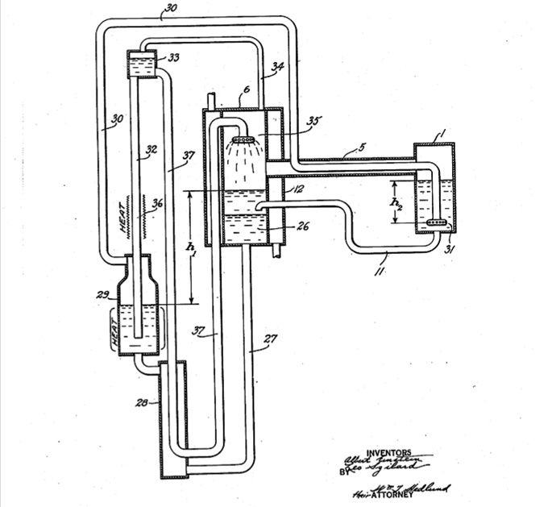

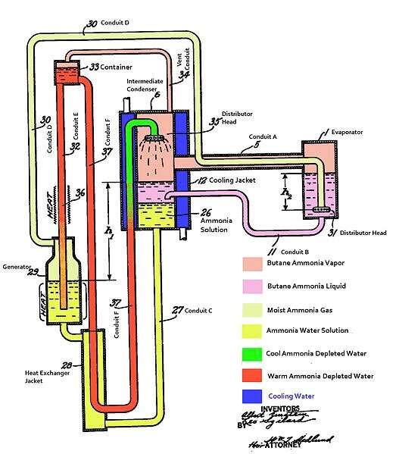
2nd Read Image: Labeled Version

