Family Paideia Seminar Plan
Text: Relativity by M. C. Escher
Ideas, Values: Gravity, Home, Relativity, Space
Pre-Seminar Content
Big Ideas Chat:
Have everyone (adults as well as children) go to their favorite place in the family home. Then imagine what it would be like if they could look through walls and see into all the rest of the rooms from that vantage point. Now come back together and talk about what the family dwelling looks like from each perspective.
1st Read:
Display a large version of M. C. Escher’s print, “Relativity,” for a few days prior to the discussion, either with a print or by leaving it up on a screen. Allow family members to discuss, sketch, and write about various aspects of the print as time permits.
Vocabulary:
Discuss with family members any vocabulary that they will need to interpret the image. Work together to get comfortable with the ideas represented by these terms: gravity, relativity, inside and out, up and down, and so on.

2nd Read:
Distribute smaller prints of the image, one to each participant. Give each several sheets of plain paper along with some colored pencils (plain, #2 pencils will work). Have each person sketch a part of the image just for fun and then share what details they discover by “copying” part of the print. Finally, have each participant number the four sides of the print (top = 1, right side = 2, bottom = 3, left side = 4) for each reference during the discussion.

Pre-Seminar Process:
- Share why you are having the discussion.
(Sample script from our classroom Paideia Seminars: Modify to fit your household.)
“A Paideia seminar is a collaborative, intellectual dialogue about a text, facilitated with open ended questions.”
“The main purpose of seminar is to arrive at a fuller understanding of the textual ideas and values, of ourselves, and of each other.”

- Describe what you want to accomplish.
- Set a Family Goal.
- To balance the talk time
- To refer to the text
- To ask a question
- To speak out of uncertainty
- To build on others’ comments

Seminar Questions:

- Opening (Identify main ideas from the text):

  - If your grandfather gave you this work of art as a gift and you decided to hang it in your room, which way would you hang it? Which side (1, 2, 3, or 4) would be “up”?
Have younger kids share first if they feel comfortable, and go around by age. (Don’t share why until everyone has had a chance to answer.)

- Why? (anyone can share)

- Core (Analyze textual details):
- Within the world of this picture, which detail strikes you most forcefully? Why?

- Why do you think Escher titled this work “Relativity?”

- Which way is “up” in this picture? How do you know?

- Why do you think the people in this world don’t have faces?

- What other space (real or imaginary) does this space remind you of?

- Closing (Personalize and apply the ideas):
- Which figure in “Relativity” do you most identify with? Why?

Post-Seminar Process:

“Ask each person what they liked most about the discussion.”

- Have the family do a quick check of the discussion goal.

Post Seminar Content:

- Transition to Writing:
Have participants brainstorm everything they said, heard, or thought during the seminar on “Relativity” that they could use to draw a similar picture of their own family home.

Talk together about the kinds of things that your family members spend most of their time doing. Where in the home do they do these things?

- Writing:
After examining and discussing M.C. Escher’s “Relativity,” create a drawing that shows your family home from the perspective of your favorite place within that home. Use your imagination! And show yourself and the rest of the family doing characteristic things.

Start by making a preliminary sketch of the world inside your home and share with the other members of the group. Examine their sketches as well. Then have everyone create their own “Relativity” masterpieces! Display each in the location within the home where it was created and then have a “gallery walk” where the whole family examines each picture.

This Paideia Lesson Plan was created by:

Name: Terry Roberts
Organization: National Paideia Center

*Text is attached if open sourced.

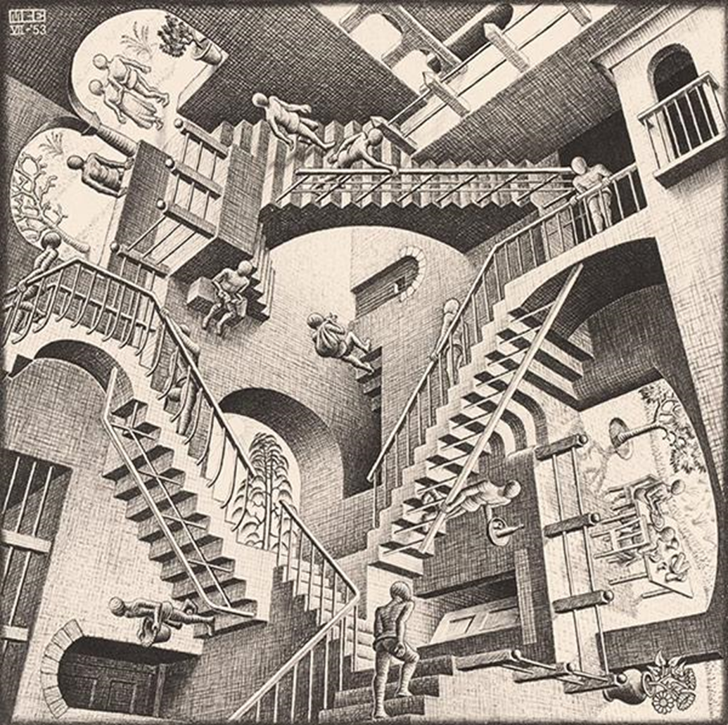
Click or tap here to enter text.

